**3.1.5 Scenarios**

In the 4+1 architecture, the "1" stands for the *scenarios*. This section describes and illustrates the interactions between objects and process, or better said, between actors and use cases. The use case diagrams represents the functionality and requirements of the system, such as generating a schedule, managing the account information, etc.

The system three types of users: public users, students, and admin. The *public users* can sign up into the system, and become a *student*, therefore interact with the system. As said before, the system goals is to generate a schedule out of the *student* preferences, course choices for the current semester and his own personalized list of taken classes. On the other side, the *admin* does not have the same functionalities as the *student* and a *public user*. First, an admin cannot sign in, as his/her account is already in the database. Second, the *admin*'s system goal is to mainly manipulate the course and section database. This includes adding, deleting, and modifying data. However, the *admin* and the *student* still shares some functionalities; both can login, edit their account (except the *admin* cannot change his username), reset their password if forgotten, login and logout.

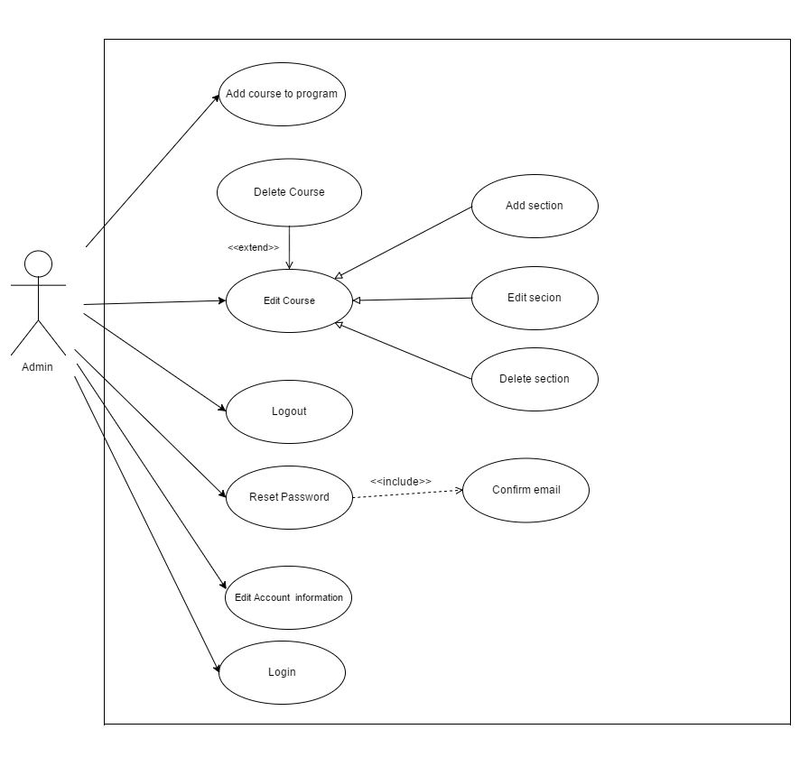

Figure : Admin Use Case Diagram

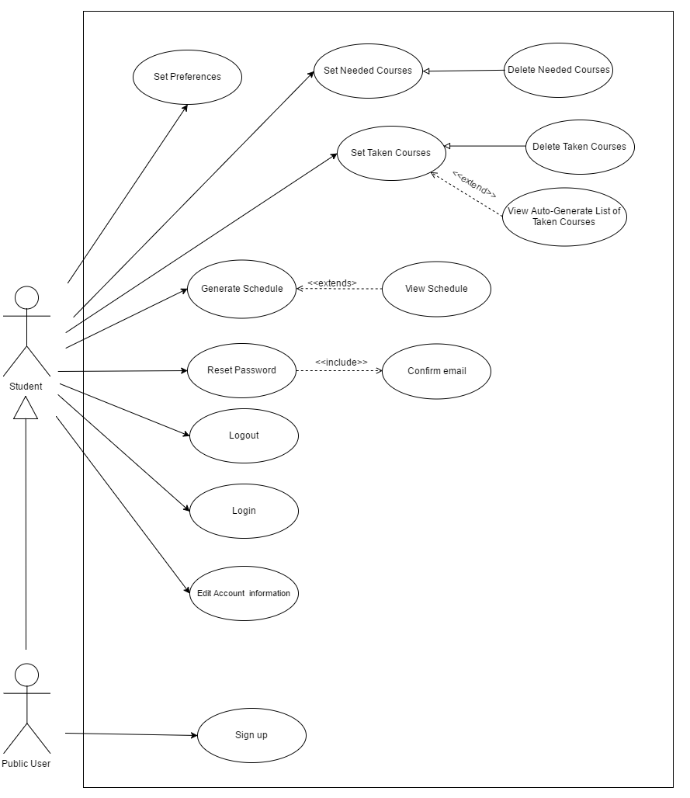

Figure : Student Use Case Diagram